**“Welcome To The Future Of Data Management With Our Cutting - Edge Project: Advanced Data Management Through QR-Enabled ID Cards”.**

**#INTRODUCTION:** Our project enhances the management of student Information by integrating QR technology into ID cards. Each card features a QR code that offers two levels of access: general information available to anyone who scans the code, and a secure section containing private documents accessible only with a password. This system eliminates the need for students to carry physical documents, as all the important information is securely stored.

Data updates are efficiently managed by the administration team with the support of advanced AI, ensuring both accuracy and reliability. The landing page is user-friendly and makes it easy to download data by simply scanning the QR code. Parents can easily track their child's academic progress and school activities, keeping them informed and engaged. This improved communication helps connect parents and educators, fostering a more collaborative approach to student development.

**#KEY BENEFITS: 1. Enhanced Security:** Dual-layer access for both public and password-protected information.

**2. Efficient Management:** AI-assisted updates managed by the administration team.

**3. Easy Access:** Simple landing page for quick data downloads by scanning the QR code.

**4. Reduced Paperwork:** Streamlined process that minimizes administrative workload.

**#OBJECTIVE:** **1. Go Paperless:** Use digital QR codes to manage data online.

**2. Simplify School Data:** Make it easier for schools to manage and access student info.

**3. Improve Parent Access:** Allow parents to easily check their child’s performance.

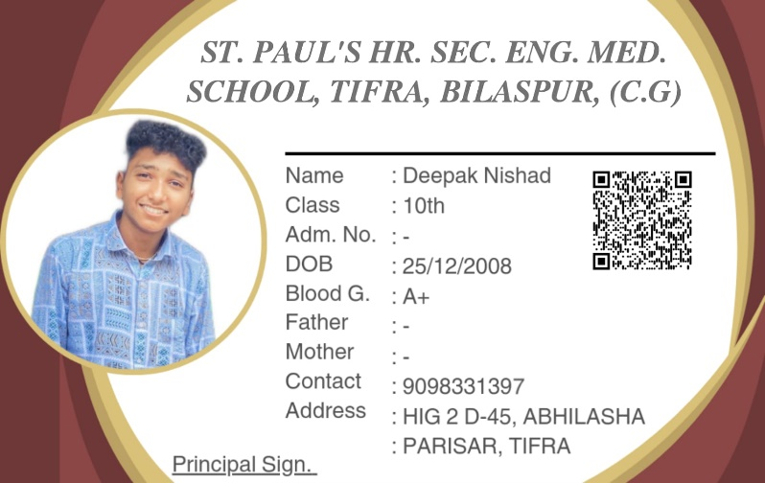

**#EXAMPLE OF ID CARD DESIGN AND FUNCTIONAL QR CODE SAMPLES:**

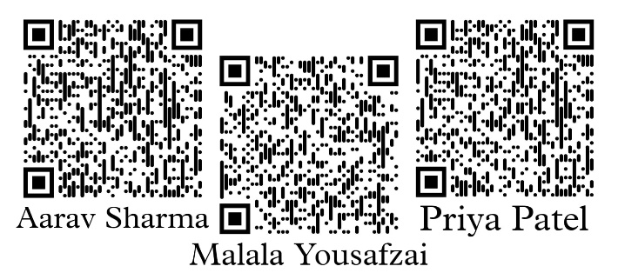

* Here is the examples of ID card designs and functional QR codes. It includes a primary example showcasing an ID card layout with a working QR code. Additionally, it features QR codes from three other individuals, demonstrating the data download functionality from their respective ID cards. Scanning any of these QR codes will illustrate the operational example.

**#WORKING PROCESS:**

**1. QR Code Issuance:** Google Sheets and QR code generators are used exclusively to create QR codes, which are linked to individual student directories hosted on GitHub.

**2. Data Access:** Scanning a QR code navigates person to a clean, user-friendly landing page, where they can seamlessly download a zip file. This archive includes a text file with general student details like – Class, Roll. No. ,Adm No. etc, and a password protected zip file containing private documents like – ID, Fees Receipt, Qualification & Certificates etc. More data available on given QR codes.

**3. Data Administration and Repository Management:** The administrative team oversees the management and periodic updating of student data on GitHub. This process is conducted on a weekly or monthly basis, with GitHub ensuring the integrity and maintenance of the repository.

**#HOW TO CREATE?**

* First, gather all essential data for each student and package it into individual ZIP files. Next, create a personalized HTML landing page for each student using Notepad++. Attach/link all the ZIP files with the corresponding HTML, making it easy to download the student’s data. Continue this process for every student, using unique numbers or IDs to keep everything organized and distinct.
* Now, start by creating a GitHub repository. Set up individual directories within the repository for each student, naming them sequentially (e.g., landing-page-1, landing-page-2, etc.). Upload each student's ZIP file and HTML file to their respective directories. After uploading, generate/create public links to each HTML file and test these links to ensure proper access. Create QR codes that link to each HTML page and verify their functionality by scanning them with a mobile device. Finally, update each ZIP file to include the corresponding QR code as a PNG inside the ZIP archive, ensuring that all resources are readily accessible and organized.

**#CONCLUSION:**

In conclusion, our project represents a significant advancement in student data management through the integration of QR technology. By embedding QR codes into ID cards, we offer a dual-layer access system that enhances both public and secure data accessibility. This innovation eliminates physical paperwork, streamlines administrative processes with AI-assisted updates, and fosters improved communication between parents and educators. The user-friendly landing page facilitates easy data retrieval, while the secure management of personal documents ensures privacy and reliability.

Our objective is clear: to transition to a paperless environment, simplify data management for educational institutions, and enhance parental engagement with real-time access to student performance. This cutting-edge approach not only reduces administrative workload but also supports a more connected and collaborative educational community.

**#Project Developer Profile:**

Deepak Nishad

Class 10th Student

St. Paul's. HR. Sec. Eng. Med. School

Tifra, Bilaspur, Chhattisgarh

**Skills and Responsibilities:**

* **Design & Development:** Personally designed and developed the ID card layout, QR code generation, and custom landing pages.
* **Data Management:** Managed data storage and organization using GitHub repositories.
* **Implementation & AI Integration:** Developed user-friendly landing pages, ensured secure access, and utilized AI for efficient data updates and management.

**Contact Information:**

* Email: deepaknishad1225@gmail.com
* Phone: +91 9098331397
* **Summary**: "By designing and implementing this system, Deepak Nishad has delivered a secure, efficient, and paperless solution for managing student information, utilizing advanced QR technology to streamline data access and enhance communication."

**#ADDITIONAL INFORMATIONS:**

**1. Hosting the Landing Page:** Currently, I’m using GitHub to host a landing page for this project, which works fine as the example. However, for a more robust implementation, you could opt for a dedicated website hosting service rather than GitHub Pages.

Additionally, you can use an website where you can create a post named "Class 10" (or the appropriate class designation). This post would contain a list of all student names along with their download links in serial order. This method helps in organizing and managing download links efficiently.

**2. Production Changes for ID Cards**: By creating the ID cards as usual and then applying a QR code sticker to each one. This approach has the advantage of being easier to update. If a QR code is damaged or destroyed, you can simply replace the sticker rather than reissuing an entirely new ID card.

**________________________________________________________________________________**